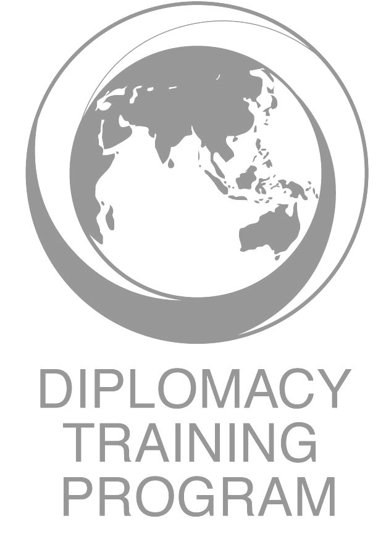

Capacity Building on Business and Human Rights (BHR, the OECD Guidelines on Responsible Business Conduct (RBC) and National Contact Points
May 8 – 12, 2026, Jakarta, Indonesia

In In Partnership with the Indonesian NGO Forum on International Development (INFID)

Schedule – Final (v6)

 | Friday 8th May | Sat 9th May | Sunday 10th May | Monday, 11th May | Tuesday 12th May
8:30 – 9:00 |  | Recap and 2 Participants Presentations | Recap and 2 Participants Presentations | Recap and 2 Participants Presentations | Recap and 2 Participants Presentations
Morning 1  9:00 – 10:30 | Opening Ceremony  Welcome remarks from partners/ Aksel Tomte, NIHR, Patrick Earle - DTP , Australian Embassy Representative (TBC)  Siti Khoirun Ni’mah, Director, INFID | Introduction to the OECD Guidelines for Multinational Enterprises on Responsible Business Conduct & Key Chapters – Human Rights, Environment, Labour – impacts on Women and Indigenous Peoples | Lodging Complaints with the NCP –  How Reflections on the NCP Process –  Shin Young Chung Reflection on the effectiveness of Korean NCP (structure, Independence, complaint handling track record)  to do it and what to Consider | Indonesia’s HRDD Law Reform and the creation of Indonesia’s NCP  Nurkholis Hidayat – (Harris Azhar Law Firm / DTP Alumnus) | Dialogue on BHR and HRDs with, 2nd Secretary of Embassy of Norway to Indonesia – Truls Loke Desbans
Facilitator | INFID - Syafira Khairani | Serena Lillywhite | Serena Lillywhite | INFID - Syafira Khairani | DTP
10:30-10:45 | Morning Break | Morning Break | Morning Break | Morning Break | Morning Break
Morning 2  10:45 – 12:30 | Participant Introductions /Expectations / Walk through Schedule / Materials  Key Issues  Housekeeping etc , Safeguarding | Introduction to the OECD Guidelines for Multinational Enterprises on Responsible Business Conduct Complaint Mechanism | NCP Role Play activity – NCP & Company Mediation | Australian NCP: structure, ways of working, governance advisory board, cases, - Bryce Williamson, AusNCP – & Shiv Martin,  the Independent Examiner | Revisiting the Issues and Outstanding Questions - Feedback and reflections on visits – Next Steps in Engagement and Advocacy on creation of Indonesian NCP etc
Facilitator | INFID/DTP | Serena Lillywhite | Serena/Intan Kusumaning Tiyas | Serena Lillywhite | INFID-DTP
12:30-1:30 | Lunch Break | Lunch Break | Lunch Break | Lunch Break | Lunch Break
1:30 – 2:00 | 3 x Participants’ Presentation | 3 x Participants’ Presentation | 3 x Participants’ Presentation | 3 x Participants’ Presentation
Afternoon 1  2:00 – 3:30 | Setting the Scene - Current Context for BHR in Indonesia –  - Sri Palupi,  - Anis Hidaya, Chair, KomnasHAM  Presentations & Discussion | Brief Review of OECD Watch Database / Indonesia Cas es  Shin Young Chung reflects on learnings from POSCO Int’l Papua Palm Oil Case recent Myanmar Case:  Sharing Some Cases and BHR Advocacy in Indonesia -  Amaliah Falah Alam, Gita, | Serena Lillywhite Reflection on Australian Model and how it has evolved / Shin Young and Serena reflect on NGO efforts to reform NCPs | Norwegian NCP: structure, ways of working and linkages with responsible business conduct laws  Presentation by Ase Sand, Senior Advisor, Norway NCP  Q & A - Discussion | Course Feedback and Evaluation
Facilitator | INFID - Syafira Khairani | Serena Lillywhite/INFID | DTP/INFID | Aksel Tomte & Serena Lillywhite | DTP/INFID
3:30-3:45 | Afternoon Break | Afternoon Break | Afternoon Break | Afternoon Break | Afternoon Break
Afternoon 2  3:45 – 5:30pm | Introduction to the UNGPs on Business and Human Rights - Protect Respect and Remedy Framework and Focus on Human Rights Due Diligence - Indonesian expert on BHR – Serena Lillywhite | Introduction to the NCP Mechanism for Complaints and Remedy - Models for Indonesia  Ridho Pratama, Fildza Teddy Wakum  Group Work - Hand out preparations for role play | Reflections & Recap - Indonesia’s Accession Process and what should an Indonesian NCP look like?  Some key questions – structure / location in government etc | 5.00 – 6.30pm - Afternoon Trea/Reception / Networking at Australian Embassy - | Closing Ceremony and Certificates
Facilitator | INFID - Syafira Khairani | Serena Lillywhite | Intan Kusumaning Tiyas | DTP-INFID
 | Diary Exercise | Diary Exercise | Diary Exercise | Closing Dinner
Evening Events | Welcome Dinner | Free Time | Free Time | Closing Dinner

